**PROJCT NO : 6**

**AIM:** **Write an appropriate language description for a layman language which can do mathematical operations using English like sentences.**

**EXAMPLE:**

Add 100 ,200,300,400 . Sub 250 from result.

Mul 400 to it. Div the answer by 2. Show me

the answer.

# LAB9: Yacc useful for your language / any other highlevel langauge.

**Group Members:**

1. Kathiriya Darshak (IT057)
2. Limbani Nihal (IT064)
3. Karia Stuti (IT055)

|  |  |
| --- | --- |
| Regular Defination | Examples: |
| Keywords | From, from, Show, show, by, to, it, number, and, result, the, me, Answer, answer |
| Operation | Add, Sub, Mul, Div |
| Digit(Number) | [0-9] |
| Que. Mark | “?”//end of line |
| White Space | (Tab | Newline)**+** |
| Letter | [A-Za-z] |

**Grammer:-**

E->S

S-> OPERATION |SHOW

OPERATION -> NUMBER SEMI | NUMBER | KEYWORD

NUMBER-> SEMI NUMBER | KEYWORD | QUE

SHOW-> SHOW KEYWORD

KEYWORD-> KEYWORD | QUE

* **lab9.l**

%{

#include<stdio.h>

#include "y.tab.h"

%}

%%

"Add"|"add"|"Sub"|"sub"|"Mul"|"mul"|"Div"|"div" {printf("<%s, OPERATION>\n", yytext); return OPERATION;}

"From"|"from"|"by"|"to"|"it"|"number"|"and"|"result"|"Result"|"the"|"me"|"Answer"|"answer" {printf("<%s, KEYWORD>\n", yytext); return KEYWORD;}

"Show"|"show" {printf("<%s, KEYWORD>\n", yytext); return SHOW;}

"," {return SEMICOLON;}

[0-9]+ {printf("<%s, NUMBER>\n",yytext); return NUMBER;}

"?" {printf("<%s, QUESTION MARK>\n",yytext); return QM;}

\n {return NL;}

. {}

%%

int yywrap(void)

{

return 1;

}

* **lab9.y**

%{

#include<stdio.h>

#include "y.tab.h"

int yyerror(char *s);

int yyparse(void);

%}

%token OPERATION KEYWORD SHOW SEMICOLON QM NUMBER NL

%%

E : S NL { return 0;}

S : T {printf("\nYour Given String is Valid\n\n");}

T : OPERATION NUMBER SEMICOLON NUMBER SEMICOLON NUMBER SEMICOLON NUMBER QM |

OPERATION NUMBER KEYWORD KEYWORD QM |

OPERATION KEYWORD KEYWORD KEYWORD NUMBER QM|

SHOW KEYWORD KEYWORD KEYWORD QM

%%

int main()

{

while(1)

{

printf("Enter your language input:");

yyparse();

}

}

int yyerror(char *s)

{

fprintf(stderr,"%s\n",s);

exit(0);

}

**OUTPUT:**

**Case: Valid Input**

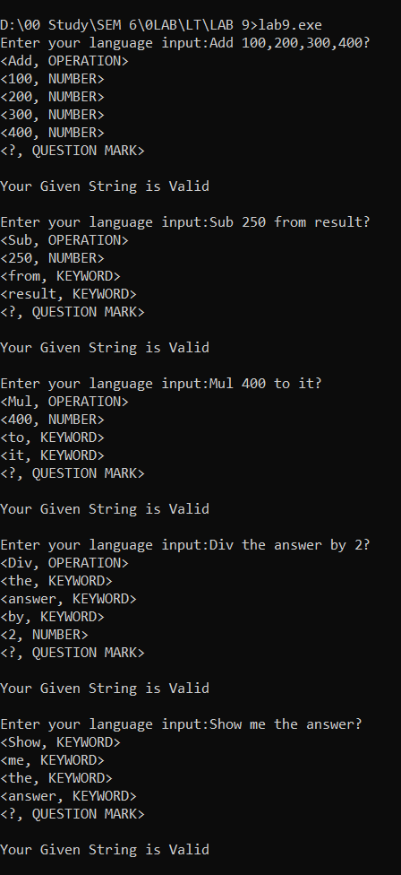

**Case:** Language seen Some Case sensitive Input.

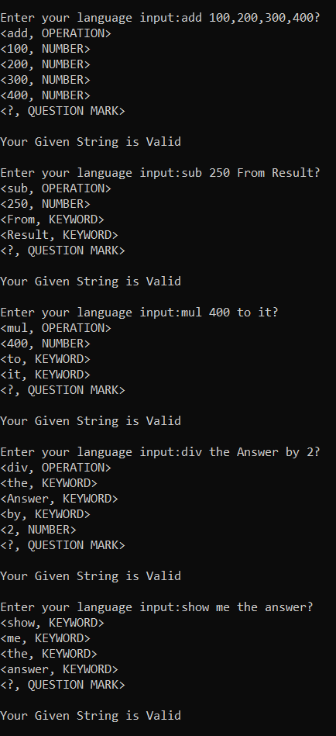

**Invalid Input Error:**

If user enter number in word form then:

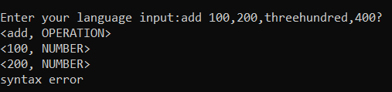

If user forget to enter semicolon in between two number then:

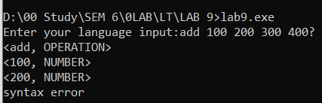

If user forget to enter “?” at the end then:

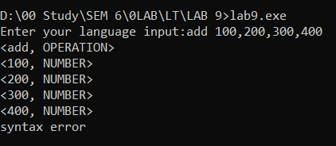

If user enter invalid case Input then:

